Image | 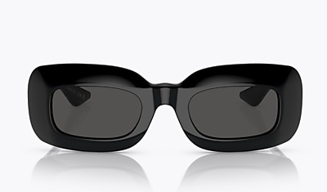
Brand | OLIVER PEOPLES
Model Name | 1966C
Price | RS 5850
PRODUCT DETAILS

